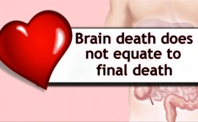
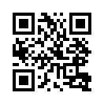
Brain death does not equate to final death
Since the beginning of organ
transplantation brain researcher
Professor Dr. Roth
says, that brain death of a human
does not equate to final
death.
Since the beginning of organ transplantation brain researcher Professor Dr. Roth says, that brain death of a human does not equate to final death. ”Neither a respiratory arrest nor the absence of deep brainstem reflexes [...] can eventually capture remaining brain functions with complete
certainty. [...] The safest most reliable diagnosis that can be made at all […] of a coma patient
is the presumption that there is an irreversible damage of the brain and that the patient
will not regain consciousness anymore.” The judgment that a brain dead person cannot be regarded as dead, is also endorsed by Rainer Beckmann,judge and lecturer in Medical Law: “The living body is the physical sign of the presence of the soul. Patients with failed brain function are near to death but not dead yet. Therefore they must be treated as living beings.”
from ch
Sources:
http://www.mmnews.de/index.php/i-news/15126-organ-entnahme-ist-mord
https://www.kla.tv/8618
This may interest you as well:
---
Kla.TV – The other news ... free – independent – uncensored ...
- what the media should not keep silent about ...
- Little heard – by the people, for the people! ...
- regular News at www.kla.tv/en
Stay tuned – it’s worth it!
Free subscription to our e-mail newsletter here: www.kla.tv/abo-en
Security advice:
Unfortunately countervoices are being censored and suppressed more and more. As long as we don't report according to the ideology and interests of the corporate media, we are constantly at risk, that pretexts will be found to shut down or harm Kla.TV.
So join an internet-independent network today! Click here: www.kla.tv/vernetzung&lang=en
Licence: Creative Commons License with Attribution
Spreading and reproducing is endorsed if Kla.TV if reference is made to source. No content may be presented out of context.
The use by state-funded institutions is prohibited without written permission from Kla.TV. Infraction will be legally prosecuted.

