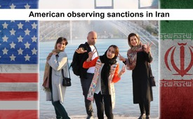
An American Observing Sanctions in Iran
American sanctions on Iran are affecting the country dramatically. Usually, my content is about uplifting human stories--and I'll have a cool video about Iran soon--but I felt it would be unfair not to show the current story of sanctions too. Sanctions are hurting ordinary people from the most pro-American populace on the planet (I know that's hard to believe but true).
-
from Peter Santenello
Sources:
https://www.youtube.com/watch?v=jxkHlekKtPY
This may interest you as well:
#Iran-en - www.kla.tv/Iran-en
#InsideIran-en - www.kla.tv/InsideIran-en
Kla.TV – The other news ... free – independent – uncensored ...
- what the media should not keep silent about ...
- Little heard – by the people, for the people! ...
- regular News at www.kla.tv/en
Stay tuned – it’s worth it!
Free subscription to our e-mail newsletter here: www.kla.tv/abo-en
Security advice:
Unfortunately countervoices are being censored and suppressed more and more. As long as we don't report according to the ideology and interests of the corporate media, we are constantly at risk, that pretexts will be found to shut down or harm Kla.TV.
So join an internet-independent network today! Click here: www.kla.tv/vernetzung&lang=en
Licence: Creative Commons License with Attribution
Spreading and reproducing is endorsed if Kla.TV if reference is made to source. No content may be presented out of context.
The use by state-funded institutions is prohibited without written permission from Kla.TV. Infraction will be legally prosecuted.

