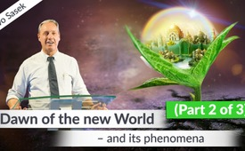
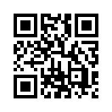
Dawn of the New World - and its phenomena (Part 2 of 3)
Rise of the New World: Today you will experience the 2nd part of the speech of Kla.TV founder Ivo Sasek. It is important to let go of old traditions and deal with misunderstandings. Let's not resist the New World, which is about to burst forth within us.
Just in time for Christmas Kla.TV will take you to the 2nd part of the international online conference by Ivo Sasek, about the dawn of the new world and its phenomena. More time for self-discovery is the motto - and also more 1st hand information. But, those who find it difficult to let go of traditions or prefer superficial philosophies should be warned: part 2 of this trilogy really goes deep to the core of things - where things really matter. Nothing for notorious caterpillars who do not like butterflies. If you can't take anything too new ... don't complain ... just switch to one of Kla.TV’s 11 other program categories.
from is.
Sources:
-
This may interest you as well:
#DawnOfNewWorld-en - of the New World - www.kla.tv/DawnOfNewWorld-en
Kla.TV – The other news ... free – independent – uncensored ...
- what the media should not keep silent about ...
- Little heard – by the people, for the people! ...
- regular News at www.kla.tv/en
Stay tuned – it’s worth it!
Free subscription to our e-mail newsletter here: www.kla.tv/abo-en
Security advice:
Unfortunately countervoices are being censored and suppressed more and more. As long as we don't report according to the ideology and interests of the corporate media, we are constantly at risk, that pretexts will be found to shut down or harm Kla.TV.
So join an internet-independent network today! Click here: www.kla.tv/vernetzung&lang=en
Licence: Creative Commons License with Attribution
Spreading and reproducing is endorsed if Kla.TV if reference is made to source. No content may be presented out of context.
The use by state-funded institutions is prohibited without written permission from Kla.TV. Infraction will be legally prosecuted.

