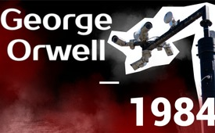
George Orwell - 1984 (English)
"1984": The British science fiction film by Michael Anderson from 1956, shot in black and white, was based on the novel of the same name by George Orwell. The story plays a world in which there are only three major powers waging war with each other. The film portrays the dark vision of a totalitarian surveillance state. Monitored streets, children spying on their parents. You can't even escape the control of the party in your own private rooms. Using the techniques of reality control and double-think, the party dominates people's memory. But there is something they cannot control ...
George Orwell - 1984 (English)
from Author ???
Sources:
- https://www.youtube.com/watch?v=Wl4kt4kUE88
This may interest you as well:
---
Kla.TV – The other news ... free – independent – uncensored ...
- what the media should not keep silent about ...
- Little heard – by the people, for the people! ...
- regular News at www.kla.tv/en
Stay tuned – it’s worth it!
Free subscription to our e-mail newsletter here: www.kla.tv/abo-en
Security advice:
Unfortunately countervoices are being censored and suppressed more and more. As long as we don't report according to the ideology and interests of the corporate media, we are constantly at risk, that pretexts will be found to shut down or harm Kla.TV.
So join an internet-independent network today! Click here: www.kla.tv/vernetzung&lang=en
Licence: Creative Commons License with Attribution
Spreading and reproducing is endorsed if Kla.TV if reference is made to source. No content may be presented out of context.
The use by state-funded institutions is prohibited without written permission from Kla.TV. Infraction will be legally prosecuted.

