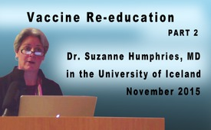
Vaccine Re-education (Part 2)
Dr. Suzanne Humphries is an American internist and kidney specialist independent from the pharmaceutical industry. During her decades of practice as a doctor, she experienced that common medicine often causes new diseases instead of healing people. For many years she did research on vaccinations and infectious diseases which she published in her book titled “Dissolving illusions: Disease, Vaccines, and The Forgotten History”. In it she sheds light on important aspects that are still little known to the public.
We welcome you to the second part of Dr. Suzanne Humphries’ speech on the topic “Hidden facts about vaccinations and their side-effects”.
from -
Sources:
-
This may interest you as well:
#Vaccination-en - www.kla.tv/Vaccination-en
Kla.TV – The other news ... free – independent – uncensored ...
- what the media should not keep silent about ...
- Little heard – by the people, for the people! ...
- regular News at www.kla.tv/en
Stay tuned – it’s worth it!
Free subscription to our e-mail newsletter here: www.kla.tv/abo-en
Security advice:
Unfortunately countervoices are being censored and suppressed more and more. As long as we don't report according to the ideology and interests of the corporate media, we are constantly at risk, that pretexts will be found to shut down or harm Kla.TV.
So join an internet-independent network today! Click here: www.kla.tv/vernetzung&lang=en
Licence: Creative Commons License with Attribution
Spreading and reproducing is endorsed if Kla.TV if reference is made to source. No content may be presented out of context.
The use by state-funded institutions is prohibited without written permission from Kla.TV. Infraction will be legally prosecuted.

