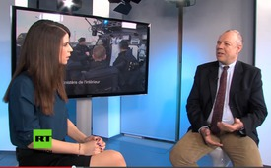
Terrormanagement - a complicated business
Russia Today (Deutsch) Interview with Christoph Hoerstel
The terrorist attacks in Paris are an absolute tragedy, but also a chain of details leaving many open questions. How can a terrorist attack of such a vast extent be planned in such a large European City? The word “terror management” hasn’t been mentioned in this context yet. Christoph Hörstel, former Afghanistan correspondent of German TV channel ARD, explains this term to us and gives some significant statements on this supposed assassination in Paris.
from original
Sources:
https://www.youtube.com/watch?v=-XdWQO_yHVU&index=4&list=TL-B1t4WLhVdM
This may interest you as well:
---
Kla.TV – The other news ... free – independent – uncensored ...
- what the media should not keep silent about ...
- Little heard – by the people, for the people! ...
- regular News at www.kla.tv/en
Stay tuned – it’s worth it!
Free subscription to our e-mail newsletter here: www.kla.tv/abo-en
Security advice:
Unfortunately countervoices are being censored and suppressed more and more. As long as we don't report according to the ideology and interests of the corporate media, we are constantly at risk, that pretexts will be found to shut down or harm Kla.TV.
So join an internet-independent network today! Click here: www.kla.tv/vernetzung&lang=en
Licence: Creative Commons License with Attribution
Spreading and reproducing is endorsed if Kla.TV if reference is made to source. No content may be presented out of context.
The use by state-funded institutions is prohibited without written permission from Kla.TV. Infraction will be legally prosecuted.

