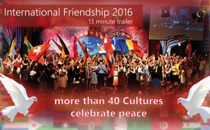
"Boundless Love" - more than 40 cultures celebrate peace (13 min. trailer)
This day is a landmark in world history. Over 40 nations professed their love towards other countries, cultures and religions. An ideological firework, with a mondial, that means a worldwide, walkway of love. Reconciliation and declarations of love – between quarrelling countries and religions.
Cultural diversity non-stop, unforgettable and earth-moving!
Powerful impressions of the mega event "International Friendship 2016", summarized in 13 minutes. Let yourself be fascinated by the worldwide walkway of love.
from -
Sources:
http://www.sasek,tv/boundless
http://www.sasek.tv/grenzenlos
This may interest you as well:
---
Kla.TV – The other news ... free – independent – uncensored ...
- what the media should not keep silent about ...
- Little heard – by the people, for the people! ...
- regular News at www.kla.tv/en
Stay tuned – it’s worth it!
Free subscription to our e-mail newsletter here: www.kla.tv/abo-en
Security advice:
Unfortunately countervoices are being censored and suppressed more and more. As long as we don't report according to the ideology and interests of the corporate media, we are constantly at risk, that pretexts will be found to shut down or harm Kla.TV.
So join an internet-independent network today! Click here: www.kla.tv/vernetzung&lang=en
Licence: Creative Commons License with Attribution
Spreading and reproducing is endorsed if Kla.TV if reference is made to source. No content may be presented out of context.
The use by state-funded institutions is prohibited without written permission from Kla.TV. Infraction will be legally prosecuted.

