Vaccination-Pestilence-Alarm: Top-vaccine-developer-warns! - by Ivo Sasek
This speech is of highest historic importance. Sasek historically keeps record of what Covid-19 did and did not do from the time of its appearance up to May 11, 2021 – this conclusion up to date is so important because another high expert vaccine developer guarantees that the Covid-vaccinations are going to ensure mass mortality. Geert V. Bossche has been working for Novartis, GlaxoSmithKline, GAVI and the Bill-and-Melinda-Gates-Foundation. Now he is urging for an immediate halt to vaccination!
The following appeal might be the most weighty one that I have ever made.
In order to keep up historical record in this speech, let’s first take a look back at the current real Covid-19-events, the state of worldwide facts up to this day, May 11, 2021. Afterwards we are going to concentrate on what is looming in the very near future according to the urgent appeal by a worldwide leading virologist, Geert Vanden Bossche.
This is not just anybody raising the alarm, this man has been a strong pro-vaccine supporter up to now. Vanden Bossche himself has been developing vaccines in the frontlines. For a very long time he worked in the fields of infection research and vaccine development for the pharma-industry; for companies such as Novartis and GlaxoSmithKline as well as for the GAVI Organization and the Bill & Melinda Gates-Foundation. He worked for them all. Inspite of that, he is now forewarning that mass vaccination campaigns against the corona virus will trigger a global catastrophe of epic dimensions. So, it’s not some assumption, it’s a statement. This expert even addressed this issue to the WHO in an open letter. Vanden Bossche is so perturbed about the current vaccination measures that he even called upon the United Nations in an urgent appeal to immediately halt all worldwide vaccination campaigns against the corona virus. If this does not happen, he says, even higher much worse and infectious variants would breed from the vaccination – just from vaccination! …and finally lead to mass mortality among humans. And listen to what this man has to say! But more about it at the end of my speech.
It is of most historical importance now to draw a conclusion up to this point on what the so-called Covid pandemic did and did not do, from the time it first emerged until now, May 11, 2021. Because if the predictions of Bossche are true and a real pandemic due to vaccinations is going to move accross the world in the near future, then it can be foreseen even now that the originators of this genocide –I’ll call them like this for a moment – then they will blame it, via mass media, on the non-vaccinated. At the moment public prosecutor’s offices everywhere should receive as many signs - and I think, also criminal charges - as possible at this present time in order to cement the Covid state of facts up to this day, as well as to outline the looming threat ahead of us. The contents of this broadcast should be distributed as widely as possible as it is of such imminent importance that we cannot act fast enough now. Please hear this call!
But now let’s talk about a scenario I want to depict merely fictitiously in order to better grasp the delicate point of this whole story: Let’s go back to the year 1347 where a real outbreak of the pestilence, the Black Death, took place. What is stirring inside us while hearing this fictitious news report – this is fiction now, right?! Imagine this as some kind of radio news report:
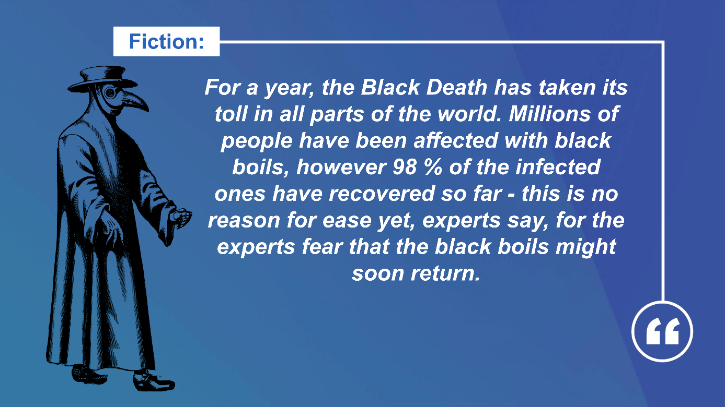
Quelle: www.kla.tv/18742
Now I’m asking you: What is stirring inside us when we hear such a news report? This was just an allegory. But what stirs inside of us? Right: The Black Death would know no mercy! Whoever he infects, he doesn’t let go again like a flu, for example, might do. And that’s it. That is the fact. - Most of the Covid patients, however, recovered in a short time, like it has always been typical for flu waves. Despite this fact, though, we are still being reprimanded by our governments in such a way as if the Black Death itself would be around! Do you understand?
Therefore, let’s now talk about what would really be going on, if a pandemic as severe as what we knew pandemics to be up to now, would truly run rampant around the world. Because the degree of severity alone must be the decisive factor to decide which general regulations have to be taken!
And the fact that this truly happened in 1347 like I’ll explain in a moment, no human being can deny. I hope with these words to sound conciliatory. But before I do so, I want to explain my approach. Let me start off: I am fully aware that you cannot compare an epidemic 1:1 with any other epidemic. Especially not the Black Death with any of the more than 80 other infectious diseases, because the Black Death embodies the worst of any known form of a pandemic. But due to the fact, that with or since Covid-19 such substantial, even actually inhuman measures have been taken as if a real pandemic similarly severe as the Black Death were rampant – and also due to the fact that the whole world has been forced to fight the threat of a pandemic with similar severity to the Black Death, that’s why I allow myself to outline my scenario according to the exact same coerced measure and severity-comparison. Are you ready?
Listen to what I’m going to say now:
Let’s place ourselves into the situation of what would happen today, if the Black Death of 1347 would have repeated itself in our days, from 2020 on. For it was exactly that kind of mass mortality which occurred in the 14th century that made us come up with the horrific term “pandemic”, was it not? That’s where we got it from. So, the term “pandemic” does in no way just stand for the speed of the spread of a pestilence, but first and foremost, for the severity level of a contagious disease or pestilence. And listen: All of Europe was infested in the middle of the 14th century, with the severity of a contagious disease like it had never happened before: Overnight, black boils appeared all over people’s bodies and they consequently died like flies.
• In the shortest of time – and listen up now what a real pandemic is like – in the shortest of time, a third of the whole European population was dead. In numbers this means:
From then 80 million inhabitants of Europe, the pestilence killed 26 million in one go. That means: Every 3rd person was dead!
And now compared to nowadays: According to the data report of the German Foundation for World Population, Europe totaled 746 million inhabitants in the middle of 2019.
I repeat: Because the world is currently being coerced into measures as if pestilence, the Black Death was rampant, I am drawing this conclusion:
Whereas the Black-Death-pandemic offered no hope for healing but persistently killed every 3rd person, our health guardians even have to admit that 91 to 98% of all Covid-infected in Europe have recovered. Do you see the difference?
So if today, you were rightly insulting all those people as covidiots and corona-deniers etc. who cannot see a severe pandemic behind the actual death figures but merely a new type of flu, we would unavoidably like in the 14th century already have to deal with consequences of such masses of dead people, I tell you: half of the world’s population would mainly do or have to do the work of gravediggers.
But let’s first concentrate on Europe only: Because of the announced severity-level of the 14th century, the Covid-pandemic would again in the shortest of time have to claim 249 million deaths in Europe alone. I emphasize: in Europe alone! And these 249 million would exclusively and only be Corona-deaths, besides all other deaths.
All other death causes and victims of the further 84 contagious diseases wouldn’t be included in this death rate yet! So, how many endlessly more million deaths would this leave worldwide? For as I said it before: For over one year the world’s entire population has been held in such an extreme and unprecedented lockdown in which the underlying danger is even suggested worse than the pestilence itself. See how this is being done. The present world population amounts to about 7 billion 865 million people. This is 7 thousand million and more. If you would apply the infection rate of 1347 to the whole world population – in its severity – in a very short time, far more than 2.5 billion people, i.e. 2,500 million people would be dead! That is a pandemic. Do you understand? – And I repeat:
If such “pandemic powers” were at work – such powers that we until just recently correctly described as “pandemic” or “pestilence”, then not only every 2nd person in Europe, but every 2nd human being in this world would primarily have to deal with the problem of the disposal of the dead. For quite some time countless media and internet reports have described the dramatically overburdened crematories in all the world. You can hear it like this hundreds of times, for example from the crematory in Nordheim, Germany; in the headlines you can read: “extra shifts because of corona”, for example in the Swiss newspaper NZZ – there are hundreds of such reports. [https://www.nzz.ch/zuerich/bildstrecke/krematorium-nordheim-zuerich-1.18119645 and www.tagesspiegel.de › Wissen.]
In other words the gravedigging would in the shortest of time become a worldwide major problem. That’s the point. We will get back to this in a moment. The decisive point however is this: Since the beginning of the so-called pandemic, not 200 million or 249 million people died in Europe alone up to this day but about more than three million people worldwide in total – that’s a bit of a difference, isn’t it?! Do you see that? And this includes all the faked Covid-deaths as have been irrefutably proven in many Kla.TV-broadcasts. In short: In reality, there was a much lower number of real Covid-deaths than indicated!
Source: www.kla.tv/18722
I conclude up to this point: So, 83 times less people died worldwide than were projected to die in Europe alone, if we were actually fighting a pandemic of the severity that we are told.
Nevertheless, Covid-19 has been obstinately propagated day and night as the worst pandemic worldwide for many months. The nations are being terrified which is a real severe crime. Therefore, let’s face up to the scenario of another comparison to the 14th century – analogue to the propagated severity – I’ll stick to this comparison and take the right to contrast it to once.
You would have to expect 2 billion 621 million 666 thousand deaths. That’s the number that would await us. However, worldwide – if you calculate it like this - the number of deaths amount to over 873 times less because, according to the Swiss Newspaper “Tagesanzeiger” for example, 99.6% of the Covid-infected people have recovered shortly after.
  - I conclude up to this point: So, 83 times less people died worldwide than were projected to die in Europe alone, if we were actually fighting a pandemic of the severity that we are told.
Source: https://www.kla.tv/18742
You see, these numbers fluctuate, I’m aware of that. But one thing has to be clear to you as well: With a pestilence, with a real pandemic, these numbers do not fluctuate. This is how you debunk the difference between ‘severe’ and ‘light’.
In Europe itself a little over one million (1,074,500) people have died so far including all those dying “with, and not of Corona” which means that in reality a whole lot less people, really died “of Corona”. We reported enough on that. So, if you compare it with a pandemic of a severity like the one we have to fight right now, the imminent number of deaths in Europe alone would have to increase up to about 230-fold!
And now let’s take a look back into the fictitious scenario of gravedigging which –Thank God – has not taken place so far.
Now listen up.
Because one single cremation takes an average of 1.5 hours, the internet is already bursting with reports of crematories worldwide which have reached their limits – with 3 million deaths worldwide in total– listen up now.
Let’s take a look at Korea for a better understanding. Seoul, a mega city with 24 million inhabitants is known to be the second largest city in the world. In the Seoul Memorial Park within the city, you find one of the largest crematories of the world, which expands over 18,000 m². The German newspaper “Bauzeitung” described this giga-crematory in their report from July 3, 2013 as a “gigantic incineration machine”. https://www.db-bauzeitung.de/architektur/eine-reise-auf-dem-pfad-zum-himmel. No wonder the local residents did fight against building this large project of the size of three football fields for 14 years. Today, Seoul, of course is glad to have this high-tech-crematory because with its eleven strong incinerators it makes up to 65 cremations a day. But now let’s play with this thought: If Seoul would have to cremate alone the 3 million Corona deaths worldwide, it would take 47,365 days, which amounts to around 130 years to do so. Do we understand? - If we Swiss people now would offer help with our altogether 26 crematories, we would make it together with Korea in about 5 years. This, however, only given the condition that we Swiss people upgraded our 26 crematories to become similar to the cremation giants like those in Seoul Memorial Park. Otherwise, it would take us together over 20 years to cremate these 3 million. Do you see what could await humanity here? For instead of eleven our crematories usually have only two incinerators. In all of this time no more further deaths would have to be added on top, of course. Otherwise it would turn out even more horrific. And this horror vision would only just amount to a bit over 3 million real casualties we’re having worldwide at this moment – if it would have to be dealt with this way.
If in only a few years, however, 240 million Europeans suddenly died, like our fictitious scenario analogue to 1347 would have required, all crematories of this world would no longer be of any use overnight. I wanted to show this, so you know what lies ahead of us. We would have to bury the dead with our own hands. At every corner we would incessantly be working as gravediggers! Because the dead bodies of a real pandemic really pose a threat to all others.
I conclude again: Whoever you are, you who are denigrating all those people asking scrutinizing questions as covidiots and Corona-deniers: Better be thankful for it, that this pestilence-monster being propagated the whole time is not really rampant in such a way as those you adhere to so faithfully depict it.
But now let’s go back to the year 2021 to the urgent appeal of high-ranking virologist Geert Vanden Bossche. If the emergency appeals of this man do apply, then the horror-scenario just depicted before might still unfold shortly – and this is the tragic thing about it: in us and our children it could unfold itself, and according to his opinion, it will unfold itself. I attached the extensive version of reporting by Vanden Bossche with this broadcast. The text of this broadcast as well as the full letter to the WHO can be downloaded from below this broadcast on our website and can be spread easily via just one click. Please make use of these features and every thinkable way of dissemination as long as it is still possible. For if this catastrophe breaks out, it will come to a disaster never seen before; as well as to mutual accusations – I even fear that it will result in murders and bloodsheds. I will therefore close with quoting from the letter of Geert Vanden Bossche that he directly sent to the WHO: “I am all but an antivaxxer. As a scientist I do not usually appeal to any platform of this kind to make a stand on vaccine-related topics. As a dedicated virologist and vaccine expert I only make an exception when health authorities allow vaccines to be administered in ways that threaten public health, most certainly when scientific evidence is being ignored. The present extremely critical situation forces me to spread this emergency call. As the unprecedented extent of human intervention in the Covid-19-pandemic is now at risk of resulting in a global catastrophe without equal, this call cannot sound loudly and strongly enough.” – end of quote.
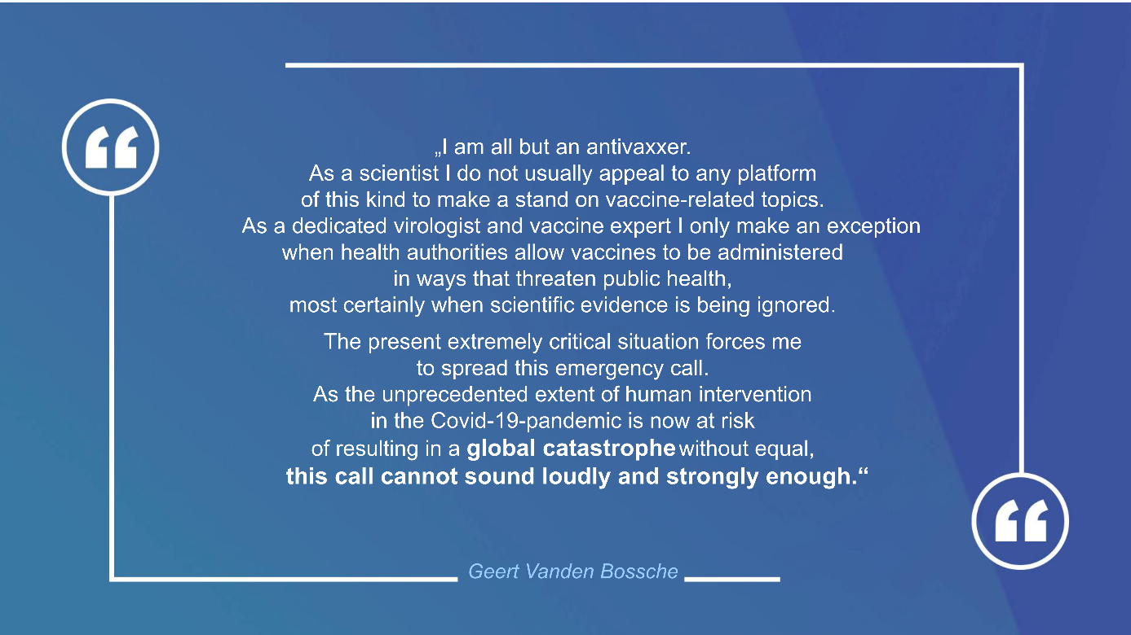Source: www.kla.tv/18742
So, here is my plea: Let this emergency call be followed by our deeds: Do spread these warnings as far as you can. Submit a criminal charge to the public prosecutor’s office in your town. In the broadcast text of my speech “PCR-test in court – lawyers accuse!” www.kla.tv/18458 you can download a ready-to-use copy for a criminal charge. Time is short! Therefore, with these warnings, educate as many people as possible who are still uninformed! Do as much as you can concerning this issue! Still this is possible… but the question is: for how long? That’s the question.
I am Ivo Sasek who has been standing before God for 44 years.
from is.
Sources:
Original article by virologist Geert Vanden Bossche
https://www.geertvandenbossche.org/
Report by „Zentral+“ – Wrong use of mass vaccination could lead to „Global catastrophe of epic dimensions”:
https://www.youmaker.com/video/7b1ac7fa-ac64-4526-bf23-dab39a16e790
also see:
https://www.youtube.com/watch?v=aPlvRC5X6e0
Open letter to the WHO:
https://www.geertvandenbossche.org/?fbclid=IwAR1rtxCWTFv99YxkWFdpwvdlcBQkv1Ity2Aacfryl5Rw3hwQQ2FBSqChzwI
also see:
https://37b32f5a-6ed9-4d6d-b3e1-5ec648ad9ed9.filesusr.com/ugd/28d8fe_266039aeb27a4465988c37adec9cd1dc.pdf
Appeal by Geert Vanden Bossch – „Urgent call to WHO: time to switch gears“:
https://www.youtube.com/watch?v=mUlDeCRDLnU&t=19s
Interview with Dr. Philip McMiliian and Geert Vanden Bossche:
https://www.brighteon.com/9a565b91-4791-430f-b47e-ebdaf806be9d
„Extra shifts because of Corona“ – Report of the NZZ, January 5, 2021
https://www.nzz.ch/zuerich/krematorium-nordheim-extra-schichten-wegen-corona-ld.1593493?reduced=true
Saxony: Crematories at their limits due to Corona: https://www.dw.com/de/sachsen-krematorien-wegen-corona-an-der-belastungsgrenze/a-56312994
A funeral undertaker of East Switzerland reports:
https://www.dieostschweiz.ch/artikel/duerfen-diese-menschen-denn-nicht-gehen-qGoO9Qd
MDR-Television «Crematories at their limits … »:
https://www.mdr.de/video/mdr-videos/c/video-492944.html
Deutschlandfunk: Vaccinations demanded for funeral undertakers:
https://www.deutschlandfunk.de/ueberlastete-krematorien-impfungen-auch-fuer-bestatter.1769.de.html?dram:article_id=490773
Philosophia Perennis: «Panicmongering with FakeNews»:
https://philosophia-perennis.com/2021/01/14/panikmache-mit-fakenews-ueberlastete-krematorien/
News Reader – Crematories:
https://news.feed-reader.net/199797-krematorien.html
SRF – Corona-Pandemic in India out of control:
https://www.srf.ch/play/tv/tagesschau/video/corona-pandemie-in-indien-ausser-kontrolle?urn=urn:srf:video:6a1c7531-27e2-4684-aea7-6212f00097cc
20minutes – Mortality Wave – Crematories reach their limits:
https://www.20min.ch/story/sterbewelle-krematorien-stossen-an-ihre-grenzen-708246146789
Tagesanzeiger on the topic of Corona deaths:
https://interaktiv.tagesanzeiger.ch/2020/keine-panik-wegen-coronavirus/
Report German Bauzeitung about the crematory in Seoul:
https://www.db-bauzeitung.de/architektur/eine-reise-auf-dem-pfad-zum-himmel/
This may interest you as well:
---
Kla.TV – The other news ... free – independent – uncensored ...
- what the media should not keep silent about ...
- Little heard – by the people, for the people! ...
- regular News at www.kla.tv/en
Stay tuned – it’s worth it!
Free subscription to our e-mail newsletter here: www.kla.tv/abo-en
Security advice:
Unfortunately countervoices are being censored and suppressed more and more. As long as we don't report according to the ideology and interests of the corporate media, we are constantly at risk, that pretexts will be found to shut down or harm Kla.TV.
So join an internet-independent network today! Click here: www.kla.tv/vernetzung&lang=en
Licence: Creative Commons License with Attribution
Spreading and reproducing is endorsed if Kla.TV if reference is made to source. No content may be presented out of context.
The use by state-funded institutions is prohibited without written permission from Kla.TV. Infraction will be legally prosecuted.

